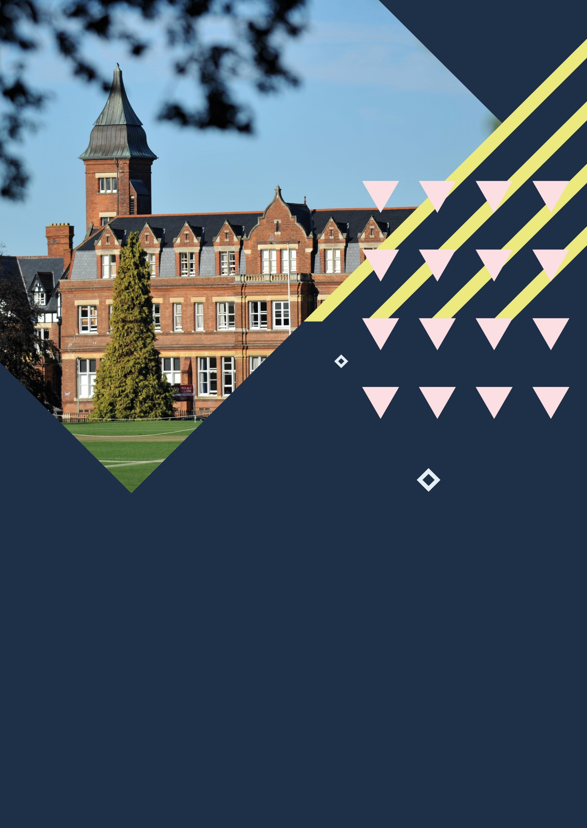



Cheltenham, Dean Close School
Centre Handbook
2026

Contents

Contents 2
Summary 3
The Centre 4
Location 5
Airport Transfers: 5
Local Amenities 7
Accommodation 9
Room Allocation 9
Housekeeping 9
Key Loss 9
Deposits 9
Meals 10
Meal times 10
Dean Close School, Cheltenham - Sample Menu 10
Technology 11
Security 11
Safety 11
Teaching 12
Placement tests Error! Bookmark not defined.
Programme 14
A typical day for students 14
Dean Close School, Cheltenham Sample Programme - Summer 2026 15
Facilities 17
Evening entertainment 17

Thank you very much for your interest in our centre in Cheltenham, Dean Close School. We hope you find everything you need in the following pages but if you have any questions or specific requests then please get in touch with us at Head Office on 0044 1244 577995.

The contents of this handbook are updated regularly. The latest version will be sent before your arrival.

We look forward to a successful summer 2026 at Dean Close School.

Summary



Boarding School

Swimming Pool

Intensive English

Performing Arts

Football
Short Transfers

The Centre

Dean Close School was founded in 1886 and has many traditional and beautiful buildings on its grounds. Situated on the edge of the town, it is easy walking distance to the centre so students can enjoy everything that Cheltenham has to offer.

It is a closed site with high security; there is CCTV on campus and the buildings have key coded doors for access, the entrance gate is locked overnight.

Student accommodation is divided between 4 main boarding houses: Shelburne House, Gate, Tower. In each house, there is a common room and at least one kitchen that can be accessed by our groups.

We divide the students up according to their age, sex and group where possible. We take into consideration any specific requests, e.g. friends who want to share. Group leaders will stay in the same house as their students. Room allocation is normally done on arrival. If you would like any further information on this, please contact us.

The school is set in 50 acres of parkland, so there are many grassy areas where students can relax or take part in sports and activities.

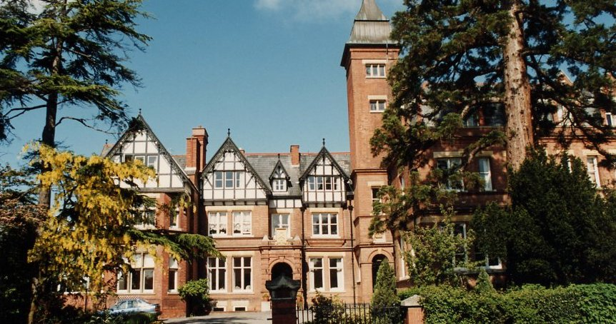
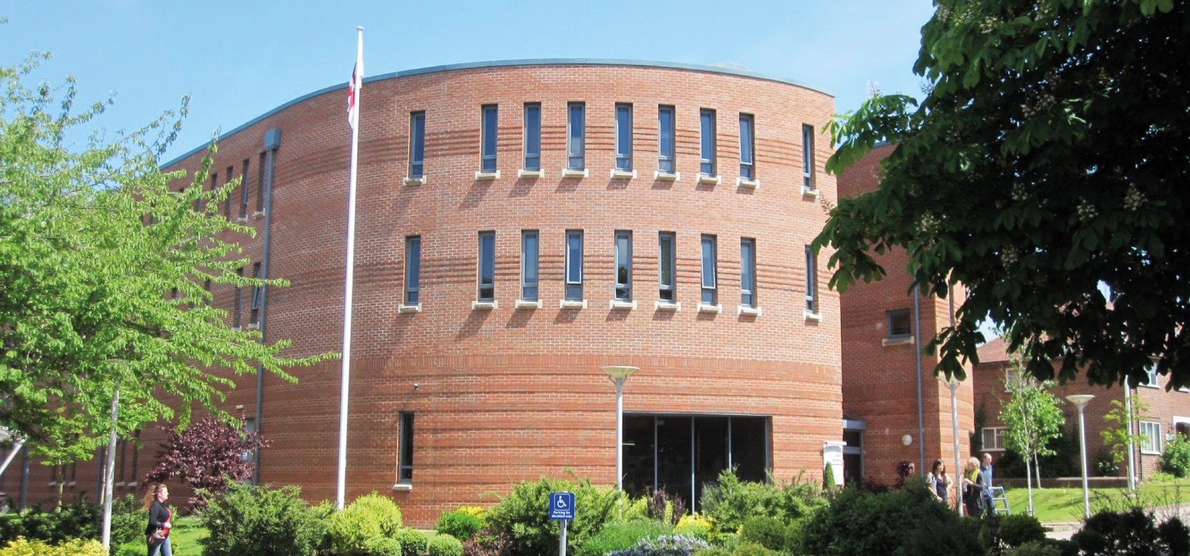

Location

Dean Close School, Shelburne Road, Cheltenham GL51 6HE

Telephone Number - 01242 258000

Population of Cheltenham - 116.45K

It is a short distance to the city centre from Dean Close School - approximately 1.2 miles (20 minutes’ walk)

Situated in the beautiful Cotswolds, Cheltenham is full of history and culture. It’s the most complete Regency town in the UK. The Regency period lasted from 1811 to 1820 and is well known for it’s stunning architecture which you can see scattered all around the town. Students can enjoy the many things to do in Cheltenham, as well as exploring the surrounding local area; famous for it’s countryside, nature and historical sites and cities.

Airport Transfers:
Bristol: 1 hour
Birmingham International: 1 hour 20 minutes
London Heathrow: 1 hour 50 minutes
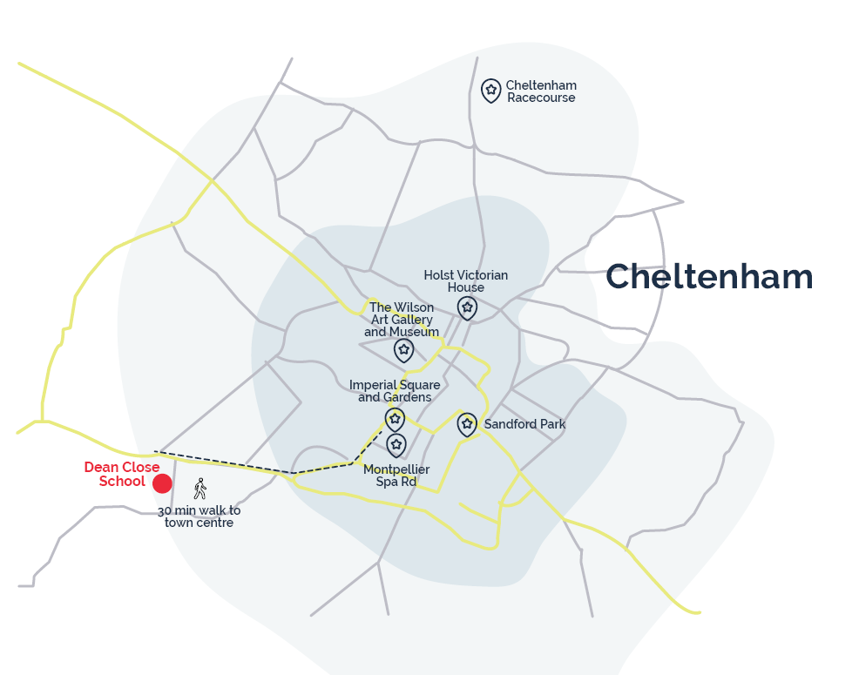
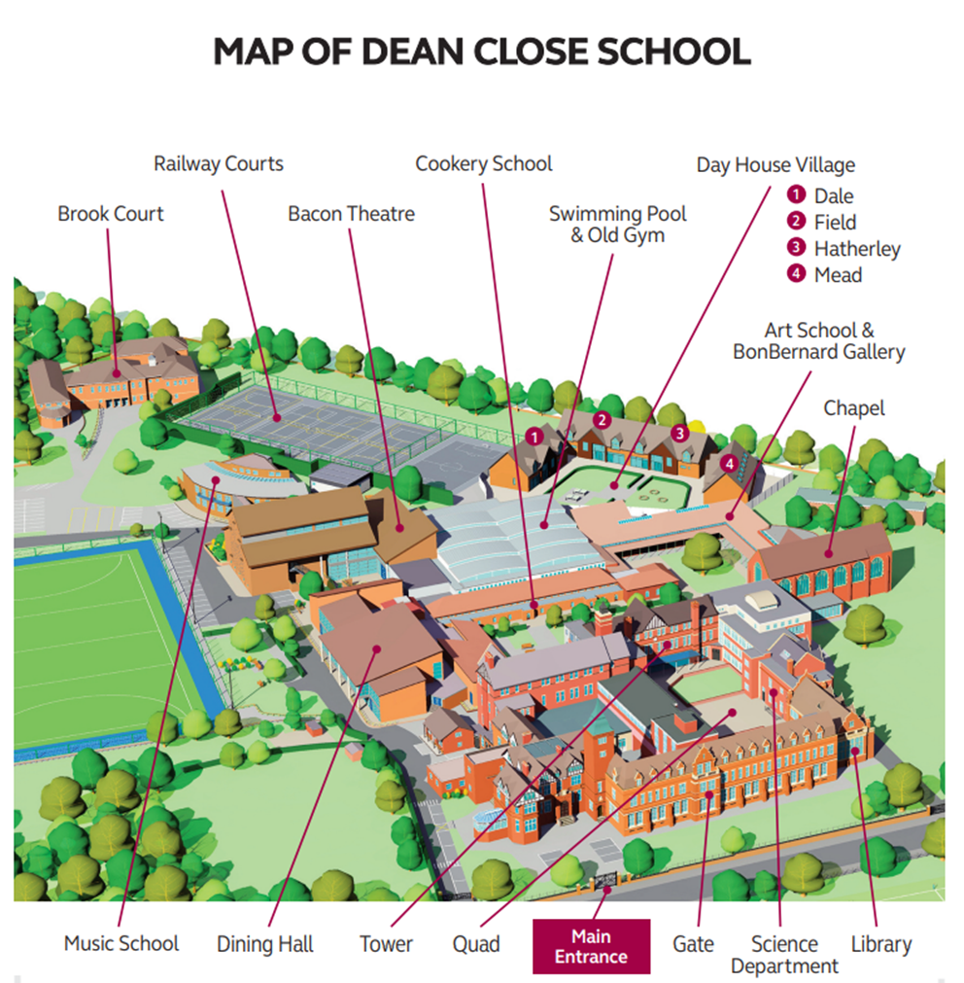

Local Amenities

Post Office
Up Hatherley Post Office
Address: 238 Hatherley Rd, Cheltenham GL51 6HB (0.7 miles / 13 minutes’ walk)

Supermarket
Tesco Express
Address: Tesco Express, Queen's Rd, Cheltenham GL50 2NH (0.6 miles / 13-minute walk)

ATM
Shell Garage
Address: 352-356 Gloucester Rd, Cheltenham GL51 7AY (0.3 miles / 6-minute walk)

Chemist
The Spa Pharmacy
Address: 12 Montpellier St, Cheltenham GL50 1SW (1.2 miles / 25 minutes’ walk)

Hospital
Cheltenham General Hospital
Address: Sandford Rd, Cheltenham GL53 7AN (1.6 miles / 30 minutes’ walk / 7 minutes’ drive)

Doctors
Address: Underwood Surgery, 139 St George's Rd, Cheltenham GL50 3EQ (1.1 miles / 22 minutes’ walk)
*N.B. If a student is ill and requires a doctor, then a Group Leader and a UKLC staff member will take the student to the NHS medical centre at Cheltenham General Hospital. The student will be required to fill out a temporary patient form and will be seen on the same day.*

Dentist
Address: Gratton House Dental Surgery, Gratton Street, Cheltenham GL50 2AS (1.3 miles/ 26 minutes’ walk)

Bus Stops
In front of the school they are approximately 60 meters away. There are frequent buses that run to the city centre and neighbouring towns.

Train Stations
Cheltenham Spa Railway Station
Address: Cheltenham GL51 8NP (0.5 miles / 11 minutes’ walk)

Coffee Shops
The Butterfly Box
The Butterfly Box is the first ever coffee shop situated in the incredible grounds of Hatherley Park. Stop by daily to enjoy a delicious barista style coffee or grab a freshly baked cake or one of Ruby's Cookies. You will find a mass of alternative milks to suit your requirements.
Address: Hatherley Park, Cheltenham GL51 3AL
Walking distance from Dean Close School: 0.6 miles (11 minutes’ walk

The Coffee Dispensary
The Coffee Dispensary is a friendly local coffee shop that love nothing more than giving customers coffee advice, as well as brewing, drinking and talking about all things coffee related. They also really love to showcase local musicians and photographers with frequent music nights and photographic exhibitions.
Address: 18 Regent St, Cheltenham GL50 1HE
Walking distance from Dean Close School: 1.6 miles (33 minutes’ walk)

Restaurants
TGI Fridays
Make every day seem like Friday! Along with mouth watering food and tempting drinks, TGI Fridays brings fun, friendliness and an extra large helping of good vibes to the table!
Address: 374 Gloucester Rd, St Mark's, Cheltenham GL51 7AY
Walking distance from Dean Close School: 0.3 miles (7 minutes’ walk)

The Lansdown
A charming British pub and restaurant hosting live music and serving real ales and pub grub.
Address: Lansdown road, Cheltenham, GL50 2LG
Walking distance from Dean Close School: 0.8 miles (16 minutes’ walk)

The Daffodil
The Daffodil restaurant is a renovated 1920’s Art Deco cinema located in the Suffolk Parade area of Cheltenham. Serving British cuisine with a strong focus on vegetarian options.
Address: 18-20 Suffolk Parade, Cheltenham GL50 2AE
Walking distance from Dean Close School: 1.3 miles (26 minutes’ walk)

Accommodation

The school has six residential houses with single, twin, triple and multi-bedded rooms and shared shower and toilet facilities. Some of the single rooms have an adjacent bathroom which is also accessible by the bedroom next door – two students therefore share a bathroom. Each house has its own common room with TV. The houses are called Shelburne, Brook Court, Tower and Fawley.

Shelburne is made up of single and double, Jack and Jill bedrooms (two bedrooms with an adjoining bathroom). There is one large common room and kitchen.

Brook Court is made up of single, double, triple and quad bedrooms, with a bathroom ratio of 1:5. There are also some single Jack and Jill bedrooms (two bedrooms with an adjoining bathroom). There is one large common room.

Tower is made up of single, double, triple and sext bedrooms, with a bathroom ratio of 1:5. There is one large common room.

Fawley is made up of single, double, triple, quint and sext bedrooms, with a bathroom ratio of 1:5. There is one common room.

Room Allocation
We divide the students up according to their age, gender and group. We take into consideration any specific requests, e.g. friends who want to share. Group Leaders will stay in the same house as their students. Room allocation is normally done on arrival. If you would like any further information on this, please contact us.

Housekeeping
Bedrooms are cleaned 5 days a week. Bedding is changed once a week. Bedding is provided but all participants need to bring their own towels. House kitchens are available to use and are to be kept clean by students, Group Leaders and UKLC team.

There are washing machine and tumble dry facilities located in the boarding houses and are free of charge. Students must provide their own washing powder.

Key Loss
Room keys are not given at this centre (can be arranged upon request for Group Leaders). If any key card is lost during the stay, there will be a £25 fee for a replacement.

Deposits
We will ask each student for a deposit of €25/£25 on arrival. We will check their rooms before they arrive and before they leave and return the money if everything is in order. If there is damage to the houses and nobody admits fault, we will ask everyone in the house to share the cost.

Meals

When the students are on campus, they will eat their meals in the dining hall on site. When they are out on full day excursions, they will be provided with packed lunches.
Cooked breakfast is supplied three times a week, and the rest will be continental.
Meal times
Breakfast: 08:00 – 08:45
Lunch: 12:30 - 13:30
Dinner: 18:00 – 18:45

If we are aware in advance, we can advise the catering staff of any dietary requirements or allergies and the canteen staff can cater to these.
*Mealtimes are subject to change
Dean Close - Sample Menu

 | Monday | Tuesday | Wednesday | Thursday | Friday | Saturday | Sunday
Breakfast | Cereal Selection  Grilled Bacon  Scrambled Eggs  Grilled Tomato  Mushrooms  Baked Beans  Pain au Chocolat  Fresh Fruit | Cereal Selection  Sliced Ham  Sliced Cheese  Sliced Tomato  Toast & Preserves  Croissant  Fresh Fruit | Cereal Selection  Local Pork Sausages  Vegetarian Sausages  Poached Eggs  Plum Tomatoes  Baked Beans  Pain au Chocolat  Fresh Fruit | Cereal Selection  Sliced Ham  Sliced Cheese  Sliced Tomato  Toast & Preserves  Croissant  Fresh Fruit | Cereal Selection  Grilled Bacon  Scrambled Eggs  Grilled Tomato  Mushrooms  Baked Beans  Pain au Chocolat  Fresh Fruit | Cereal Selection  Sliced Ham  Sliced Cheese  Sliced Tomato  Toast & Preserves  Croissant  Fresh Fruit | Cereal Selection  Sliced Ham  Sliced Cheese  Sliced Tomato  Toast & Preserves  Croissant
Lunch | Homemade Pizzas  Sautéed Potatoes  Broccoli  Sweetcorn | Beef Chilli Con Carne  Bean & Vegetable Chilli  Rice  Fine Beans  Sliced Carrots  Tortilla Chips  Sour Cream | Roast Turkey  Lentil & Veg Seeded Loaf  Roast Potatoes  Peas  Honey Roast Parsnips  Gravy | Sweet & Sour Chicken  Sweet & Sour Tofu & Veg  Rice  Broccoli  Prawn Crackers | Battered Cod  Mushroom Risotto  Chips  Baked Beans  Peas | Tandoori Chicken Legs  Vegetable Pulao  Bombay Potatoes  Sliced Carrots  Naan Bread  Mango Chutney  Roasted Coconut | Roast Pork  Lentil & Vegetable  Sweet Potato Cottage Pie  Roast Potatoes  Peas  Honey Roast Parsnips  Gravy
Dinner | Pasta Carbonara  Roast Vegetable, Tomato & Basil Pasta  Homemade Garlic & Rosemary Focaccia | Stir Fry Chicken Noodles  Stir Fry Tofu Noodles  Baby Corn  Prawn Crackers | Beef Burgers  Hot Dogs  Vegan Hot Dogs  Homemade Potato Wedges  Corn on the Cobs | Chinese Style Pork Rib Eye  Chinese Style Jackfruit & Veg  Egg Noodles  Stir Fry Vegetables | Homemade Lasagne  Lentil & Veg Lasagne  Garlic Bread  Sweetcorn | Turkey & Chorizo Risotto  Bean & Courgette Risotto  Fine Beans | Chicken Stroganoff  Mushroom, Pepper &  Vegetable Stroganoff  Rice  Red Cabbage
Technology
Wi-fi is available campus wide and is password protected. Each individual will be given a Wi-fi access code. Being a private boarding school, the internet access is firewalled as per the boarding school regulations. However, it is at the Group Leader’s discretion whether they give these details to their students. Wi-fi will be switched off between 23:30 and 06:00.

There are no public phones on site. The nearest are in Cheltenham town centre.

Security

There is CCTV coverage on campus and 24/7 duty security/wardens. The main gate is locked at midnight.

Emergency contacts: Each student will be given a wristband when they arrive, and this will have the following emergency telephone number printed on it: 00 44 1244 567695. If you need to contact the centre in the event of an emergency please call this number and follow the options for the relevant centre, this will then put you through to the person on duty.

Certain basic guidelines are common to all centres and students. Students should:
- Never walk away alone!
- Never leave the residence without permission in the evening!
- Always make sure they have understood when and where the meeting point is whilst
out on excursions!
- Always wear their identification lanyard and their UKLC wristband! *
*students found not wearing their lanyard or wristband will be fined £1

Safety

- Remember that there is a 24-hour emergency telephone number on the wristband (0044 1244 567695) and that the number for the emergency services (Ambulance/Police/Fire) in England is 999, or the single emergency number for the EU including the UK is 112 or you can call 101 to report a crime where you do not need an emergency response
- The police are there to help and protect and can be asked for assistance!
- Never respond to someone if you feel threatened, simply walk away!
- Always give your money to the UKLC management team to put in the safe and never to carry large amounts of cash around!
- Be careful crossing the road. Remember that in the UK we drive on the left!
- If you are ill or need a doctor, tell a member of UKLC staff immediately!
- Keep all windows closed when not in your bedrooms!
Insurance and valuables
Although all houses will be accessed via swipe cards, it is suggested that students try to avoid bringing very expensive items with them. If they are bringing valuables with them, it essential that they have sufficient insurance to cover any loss of damage as neither the centre nor the company can be held responsible if anything goes missing. The Centre Manager will have access to a safe if it is required.

Teaching

We know how important it is for each individual student to find their own path in language learning. We use a wide range of methods to engage and stimulate our students. This is why we have created a curriculum based on the students’ age, level and needs, structured into four different programmes:
FUN (ages 8-10)
Engaging lessons that offer a wide range of materials and activities specific for our young learners, making games into lessons and lessons into games. Available in levels A1-B1.

CONNECTION (ages 10-13)
Dynamic lessons covering a variety of topics and media, designed to engage students using tools native to the fast-paced world they are growing up in. Available in levels A1-C1.

ACTION (ages 13-16)
Lessons tailored for learners stepping into their teenage years. This programme focuses on activating students’ knowledge and competencies to balance developing a personal voice while contributing effectively to a team. Available in levels A1-C1.

PURPOSE (ages 16-18)

Lessons tailored for our students approaching adulthood, designed to kickstart their lives not only as maturing youths but also as forward-thinking global citizens. Available in levels A1-C2.

The Connection, Action, and Purpose programmes consist of three different lessons a day:

FOCUS ON LANGUAGE

These lessons aim to empower our students’ linguistic awareness and capabilities by working on all language skills (reading, writing, listening, speaking) and systems (grammar, phonology, lexis, discourse), as well as using materials relevant to exam preparation (KET, PET, FCE, CAE, TOEFL, IELTS, GESE).

FOCUS ON LEADERSHIP

This programme is designed to equip students with essential 21st-century skills, focusing on leadership development, communication and teamwork. Students build the confidence and competencies needed to grow into empowered young adults.

FOCUS ON CULTURE
These lessons combine CLIL and British culture, allowing students to use English to explore a range of disciplines, including art, literature, natural sciences, as well as the history and geography of the UK.

Placement tests
We offer classes at four levels, from elementary to advanced. Students take a placement test on their first day of classes to ensure they are placed at the correct level.

Once the tests have been marked, students won’t be told their score unless they specifically ask for it but will be placed into a class based on these results.

If students are not happy with their level, they can speak with the Course Director who will decide if it is necessary for the student to change levels.

We always try to split groups into different classes to mix nationalities, but this does depend on their levels and the numbers of students that we have on site.

We will provide all course materials including a journal and a pen.

Students are taught in class sizes up to 16.

Programme

All UKLC summer programmes include:

- 15 hours of English lessons
- Full board accommodation in residence
- Full programme of excursions, activities and evening entertainment
- 1 free leader for 15 students
- Placement test on arrival and End of Course Certificate

These are summaries of UKLC English Plus programmes** for Summer 2026 at Clifton College, Bristol:

English Plus Multi-Activity
The “typical” summer programme consisting of a wide variety of activities and sports. Sessions are structured and are coached by specialist staff. Sessions can include tennis, basketball, volleyball, swimming, photography workshops, dance, football, and drama etc. Students are moved through two or three activities on rotation in each session.

English Plus Performing Arts*
During these sessions, students passionate about dancing, acting, or singing will immerse themselves in hands-on training designed to unleash their creative potential on any kind of stage. They will not only develop their talents but also experience the thrill of live performance, collaboration, and artistic expression.

English Plus Intensive English & Community Building*
Additional English lessons for those who really want to maximise their language learning during their stay in the UK. Based on UKLC's integral community-building approach, these additional lessons aim to help students develop an active role in the school as a thriving community, with its challenges, complexities and opportunity for collective growth. The Community Building lessons focus on how to empower students to work together to find possible solutions to these needs and issues by communicating with people on campus. Students create these projects that they are responsible for in order to improve these issues on campus.

*Students aged between 11 and 17 who are enrolled on Multi-Activity or English Plus courses will be divided by age for activities where numbers allow. Students can choose whether to enrol on the Multi-Activity or an English Plus course.
All students aged between 8 and 10 will be automatically enrolled on the multi activity programme.

**These programmes vary at each centre. A minimum of 10 students applies to each programme and each student will be asked to select a 1st and 2nd option before arrival which they will join for the duration for their stay. Students who do not choose in advance will join the standard English Plus Multi-Activity.

A typical day for students

08:00 – 09:00 Breakfast

09:00 – 10:00 Lesson 1 or Sports/activities or chosen programme

10:00 – 10:15 Break

10:15 – 11:15 Lesson 2 or Sports/activities or chosen programme

11:15 – 11:30 Break

11:30 – 12:30 Lesson 3 or Sports/activities or chosen programme

12:30 – 13:30 Lunch

14:00 – 15:00 Lesson 1 or Sports/activities or chosen programme

15:00 – 15:15 Break

15:15 – 16:15 Lesson 2 or Sports/activities or chosen programme

16:15 – 16:30 Break

16:30 – 17:30 Lesson 3 or Sports/activities or chosen programme

18:00 – 18:45 Dinner

20:00 – 22:00 Evening Activities

22:00 Bedtime

This centre runs on a ‘zig-zag’, meaning the order of lessons and multi-option activities/excursions will change after a week. See example below.

Dean Close School, Cheltenham Sample Programme - Summer 2026

 |  | Morning |  | Afternoon | Evening
Week 1 | Thursday | English Test |  | Multi-Activity or  Chosen Programme | Message Disco
 | Friday | Lessons |  | Cheltenham Orientation Tour | Paparazzi or Conversation Club
 | Saturday | Lessons |  | Vlogging Workshop or  Chosen Programme | Quiz Night
 | Sunday | Oxford with Oxford University Alumni Walking Tour |  |  | Mini-Olympics or  Conversation Club
 | Monday | Lessons |  | Multi-Activity or Chosen Programme | Karaoke
 | Tuesday | Lessons | Gloucester with  Gloucester Cathedral |  | Attractions
 | Wednesday | Multi-Activity or  Chosen Programme Lessons |  |  | Film Night
Week 2 | Thursday | The Wilson – Cheltenham Art Gallery & Museum |  | Lessons | Red Vs. Blue
 | Friday | Vlogging Workshop or  Chosen Programme |  | Lessons | Trashion Show  or Conversation Club
 | Saturday | Bristol with SS Great Britain |  |  | Oscars
 | Sunday | Free time, Activities or Optional Excursion |  |  | Around the World  or Conversation Club
 | Monday | Multi-Activity or chosen Programme |  | Lessons | Talent Show
 | Tuesday | The Cotswolds: Sudeley Gardens and Castle | Lessons |  | Leaving Disco
 | Wednesday | Departures

Please note: This is a sample programme and may be subject to change. It may also be necessary to operate a zig zag programme of morning / afternoon lessons.

Facilities

- Sports hall
- Heated indoor swimming pool
- Tennis courts
- Astroturf Pitches

Performing arts lessons will be held in the theatre or dance studio.

Sports available at this centre can include - football, handball, basketball, rounders, volleyball, cricket,

table tennis, tag rugby, indoor hockey, badminton & tennis.

Evening entertainment

The UK Language Courses staff plan fantastic activities to make sure the students enjoy their evenings. For example: discos, quizzes, fashion shows, blind date, sports tournaments etc. We ask Group Leaders to encourage students to participate as much as possible and to communicate any special ideas or requests from students.

Here are a few brief descriptions of just some of our activities for students to join in on:

Around the World
Consists of a number of different stations based on activities from different countries. One staff member will be placed at each activity station. They will each represent a country and have to create an activity related to that country (for example: New Zealand – The Haka). Students will be divided into groups and given a time for each station. Students will visit each station.

Oscars Night
Involves students watching a number of scenes from selected films. They will have the chance to re-enact a famous selected scene. Creating their own script, which must be in English and costumes (out of various given equipment). Scenes will be shown on a big screen for everyone to watch. Awards will be given by UKLC staff for the best reproduction.

Speed Dating
Enables students from mixed nationalities to socialise and get to know each other whilst improving their spoken English. Students will have a short period of time to have a conversation on their interests, hobbies etc. Once the given time finishes they will move to another student and begin the same process again.

Talent Show
Gives students the opportunity to perform talents such as singing, dancing and acting in front of the whole centre! Sign-up sheets will be available in the centre a few days before the event. There will be judges who will score the performances and give positive feedback to each student who performs on the evening.

We look forward to welcoming you to Dean Close, Cheltenham in summer 2026!
